AajTak news

The results of various screen sizes are as below,

1. Maximize– The content is very definite and concise. This comprises of ticker for breaking news which is of normal size, headlines of news in column format, depending on the news the font size of the headline changes. A video option for viewing Live Tv, and scroll down option to view more content and on scrolling up and down the size of the logo changes. Here the resolution of the page is 1295 x 722.

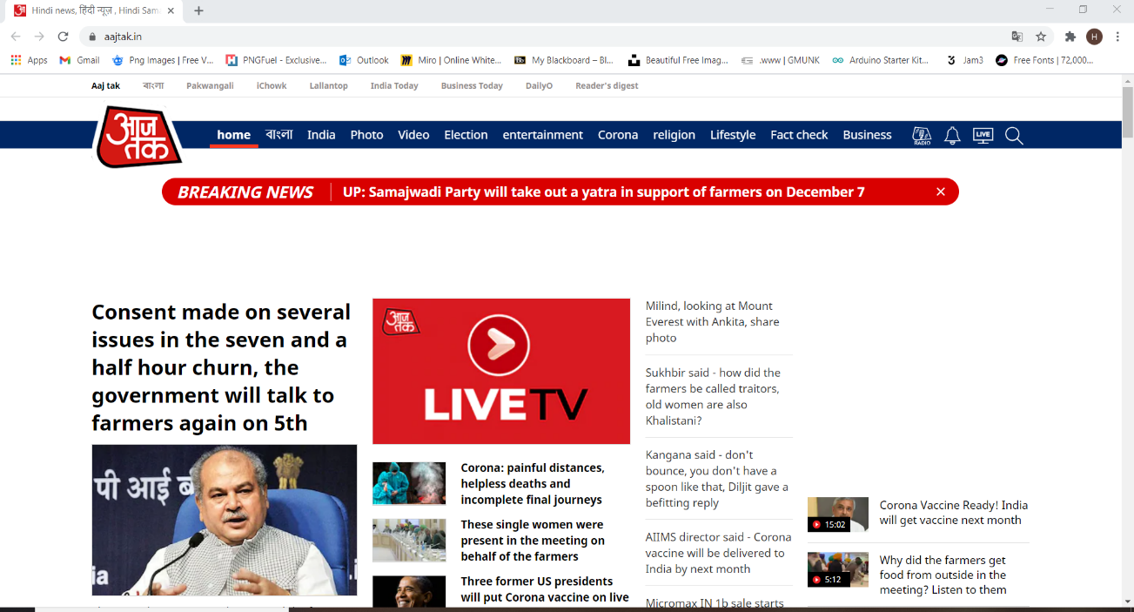

1. Minimize – On scalling the site size keeps changing with the contents size changing as well, the content fits into the screen and a new burger menu is added to view other details with 1025 x 772 resolution.

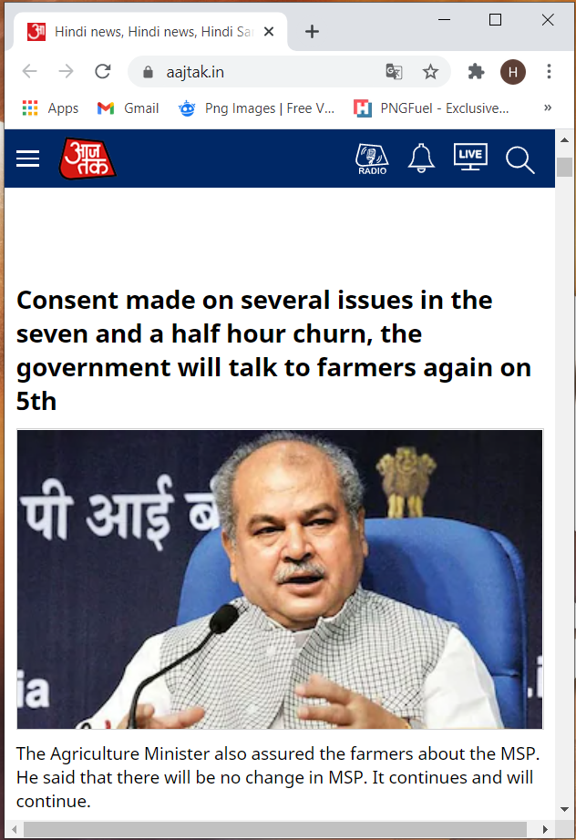

NDTV News

The results of various screen sizes are as below,

1. Maximize – The content is in full size. This comprises of a home bar, advertisement and news are categorized as per the stories, and the coronavirus block stays static even on scrolling. The resolution of the page is 1295 x 722.

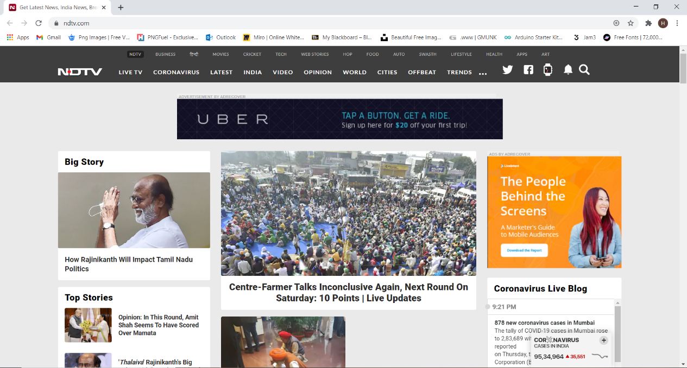

1. Minimize – There is no change in the website on minimizing or scaling, the content does not fit to the screen as Aajtak, infact it reduces and half content is shown.

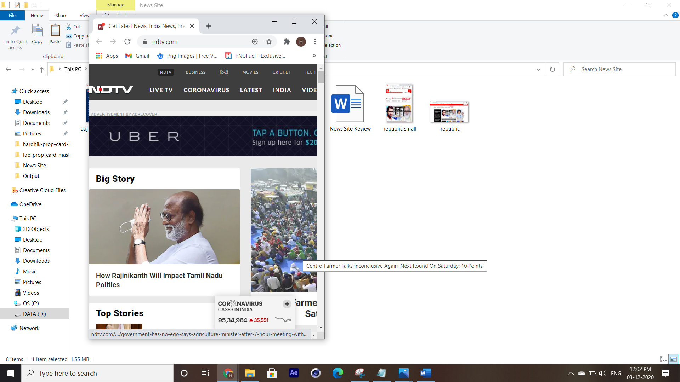

Republic India News

The results of various screen sizes are as below,

1. Maximize - The content is in full size. This comprises of a home bar, advertisement and news are categorized as per the stories, and the images are in full size and presentable. The resolution of the page is 1295 x 722.

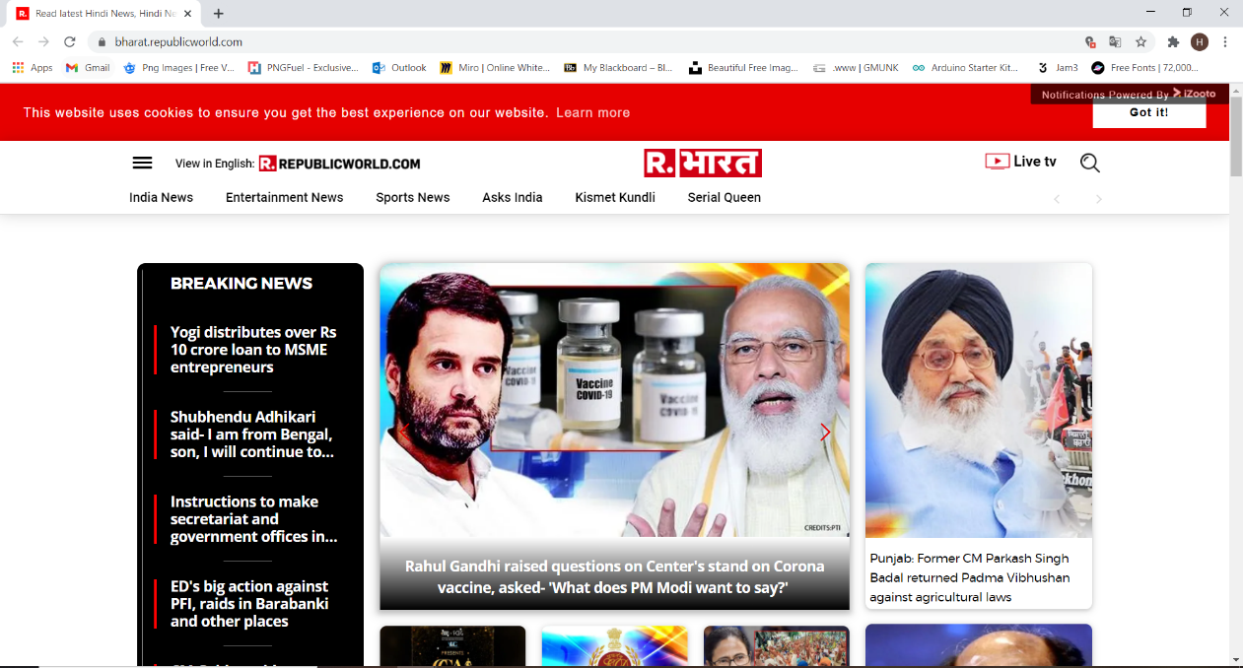

1. Minimize – On minimizing or scaling, the data compresses including the images and the all the options in home tab are not seen. And the content script overlaps as well. And on scaling up the images and the content regain its original size and shape.

